Research Report 2006

Andrea Koschinsky

Marine Geochemistry

Short description of research

The research activity in the field of marine geochemistry continued in 2005 with its focus on marine hydrothermal systems as part of the DFG Special Priority program SPP 1144: „From Mantle to Ocean: Energy-, Material- and Life Cycles at Spreading Axes“. The objective of the priority program is to quantify the processes at the mid-ocean ridges from geological and biological investigations. The target areas of this program are the Mid-Atlantic Ridge (MAR) at 15°N and 4°-11°S. The project of the IUB geochemistry group is entitled „Hydrothermal Fluids at the Mid-Atlantic Ridge as Media for the Transport of Energy and Mass from the Crust into the Hydro- and Biosphere“. The second 2-years term of this project has started in October 2005.
Apart from the hydrothermal research, our activities on experimental and theoretical investigations of interactions between dissolved metals, mineral phases and biota in the marine systems were continued. New activities in the field of marine mineral resources have been started.

Research highlights 2006

The highlight of the hydrothermal research was cruise M68/1 with R/V Meteor, where A. Koschinsky was chief scientist. This cruise continued exploration for hydrothermal fields on the southern Mid-Atlantic Ridge, which had been started as part of the SPP 1144 in 2005. Besides the revisit of hydrothermal fields discovered the year before, the combined use of an autonomous underwater vehicle AUV ABE from the Woods Hole Oceanographic Institution and the remotely operated vehicle ROV Quest from Marum, Univ. Bremen enabled the discovery of another 8 hydrothermally active sites in the area between 4 and 10°S. Temperature measurements of fluids in the young volcanic system at 5°S revealed the highest temperature ever measured so far in a hydrothermal fluid: 407°C. At 3000 m, the water depth of the vent site, this point represents the so-called critical point of seawater, which separates the subcritical from the supercritical fluid range. Gas bubbles and depleted salinity indicate “boiling’’ and phase separation. While this system is clearly characterized by subsurface leaching of basaltic rock, the newly discovered site at 8°S shows clear signatures of mantle rocks, underlining the importance of ultramafic-hosted (mantle-rock hosted) hydrothermal systems on slow spreading ridges such as the Mid-Atlantic Ridge.
Further investigation of organic metal complexation in hydrothermal fluids confirmed our preliminary data, that toxic metals such as copper are largely controlled by binding to organic ligands. This probably makes them less bioavailable. Metal analyses of organic tissue of hydrothermal mussels are carried out to compare how fluid chemistry is reflected in the uptake of heavy metals by the organisms.
Laboratory experiments with trace metals and mineral particles in seawater enhance our understanding in how the reactivity, bioavailability and enrichment of rare metals marine mineral deposits are controlled. Sorption experiments with germanium, an element of interest for semiconductor technologies, has shown a preferential uptake on Fe-oxide containing precipitates. Similar results were obtained for tellurium. A newly started DFG project on tellurium and selenium in geochemical systems in its first phase focuses on the development of sensitive analytical techniques for these trace elements in natural water and rock samples.
The increasing global demand for mineral resources has revived interest in marine minerals, such as manganese nodules. In a project funded by the BGR Hannover (German Geological Survey), the abundances of rare valuable metals in marine manganese nodules are investigated by literature search and chemical analyses in our geochemistry lab. As in the past the economic interest was mostly based on metals such as copper, nickel, zinc, and cobalt, there is a lack of reliable data for valuable trace elements, including platinum group elements, rare earth elements, and others.
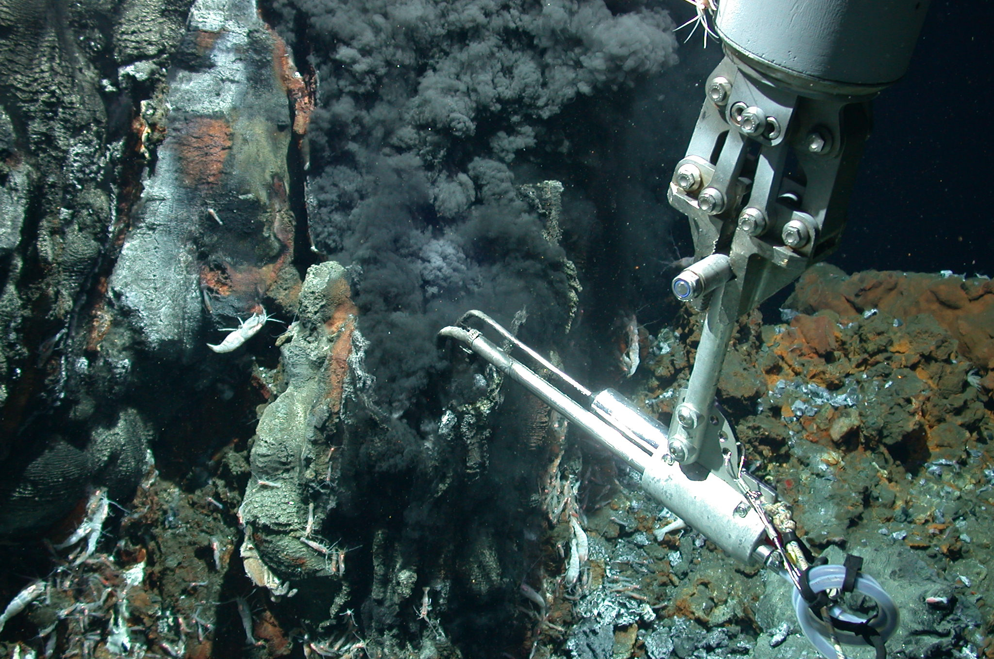
Figure: Sampling of the hottest hydrothermal vent fluid found so far (407°C) at 5°S on the Mid-Atlantic Ridge during cruise M68/1. The fluid is taken with the KIPS fluid sampling system equipped with a temperature sensor. (Picture copyright: MARUM, Univ. Bremen)

Publications in 2006

Peer-reviewed Journals
Bau, M. and Koschinsky, A. (2006): Hafnium and neodymium isotopes in seawater and ferromanganese crusts: the “element” perspective. Earth and Planetary Science Letters 241, 952-961.
Hein, J.R., Koschinsky, A., and McIntyre B.R. (2006): A mercury- and silver-rich ferromanganese-oxide deposit, Southern California borderland: Deposit model and environmental implications. Economic Geology 100, 1151-1168.
Frank, M., Marbler, H., Koschinsky, A., van de Flierdt, T., Klemm, V., Gutjahr, m., Halliday, A.N., Kubik, P.W., and Halbach, P. (2006): Submarine hydrothermal venting related to volcanism in the Lesser Antilles: Evidence from ferromanganese precipitates. Geochemistry Geophysics Geosystems 7, 24 pp. Doi:10.1029/2005GC001140.

Collaborations

1. Universität Kiel
Dr. Dieter Garbe-Schönberg
Geochemistry of hydrothermal fluids
2. Univ. Hamburg
Dr. Richard Seifert
Geochemistry of hydrothermal fluids
4. MPI Bremen
Dr. Christian Borowski, Dr. Nicole Dubilier
Geo-Bio interfaces in hydrothermal systems; metals in hydrothermal mollusks
6. Univ. Münster
Prof. Dr. Harald Strauß
Sulfur species in hydrothermal fluids
5. BGR Hannover
Dr. Christian Ostertag-Henning, BGR Hannover
Amino acids in hydrothermal fluids
Dr. Thomas Pletsch / Dr. Thomas Oberthür
Valuable rare metals in marine manganese nodules
6. Universität Bremen, MARUM
Dr. Volker Ratmeyer, Christian Seiter
Deployment of ROV during research cruises
7. US Geological Survey, Menlo Park, CA
Dr. James Hein
Valuable metals in marine minerals; synchroton methods for the solid speciation of selenium and tellurium in oxide phases
8. University of Otago, New Zealand
Dr. Sylvia Sander,
Organic complexation of metals in hydrothermal fluids
9. Universidade de Santa Maria, Brazil
Prof. Dr. Leandro de Carvalho
DAAD exchange program: metal speciation in saline fluids
10. Woods Hole Oceanographic Institution, MA
Dr. Chris German,
Deployment of autonomous underwater vehicle during research cruise

Grants

Deutsche Forschungsgemeinschaft, DFG
Project in the framework of “DFG-Schwerpunktprogramm 1144: Vom Mantel zum Ozean: Stoff-, Engergie- und Lebenszyklen an Spreizungsachsen”
DFG project no. KO 2310/2-3 (IUB projects no. 50131)
P.I.: A. Koschinsky
Includes: 1 CTA-position and 1 PhD-position and costs for research cruise M68/1

Deutsche Forschungsgemeinschaft, DFG
„Die redoxabhängige Fraktionierung von Selen und Tellur in geochemischen Systemen ...“
DFG Project no. KO 2906/4-1 (IUB Project no. 50161)
P.I.: A. Koschinsky, M. Bau
Includes: 1 Post-doc position

Contract with BGR (Bundesanstalt für Geowissenschaften und Rohstoffe) Hannover:
„Literaturstudie Manganknollen“
IUB project no. 50166
Includes: 1 Post-doc position

DAAD/PROBRAL exchange program with Brazil
„Speciation of elements of clinical and environmental relevance in saline fluids“
DAAD Project no. 415-br-PROBRAL/po-D/05/30366 (IUB Project no. 50147)
Includes: Travel costs for exchange of faculty, post-docs and PhD students

PhD students
Katja Schmidt: Temporal Variability in the Geochemistry of Hydrothermal Fluids: the ultramafic-hosted Logatchev Hydrothermal Field at 15° N, Mid-Atlantic Ridge

IUB staff members
Jule Mawick (lab technician)

Grants staff members
Dr. Herwig Marbler (Post-doc)
Dr. Thomas Schirmer (Post-doc)
Katja Schmidt (PhD student)
Daniela Meißner (lab technician)

